User Manual

**Checkers**

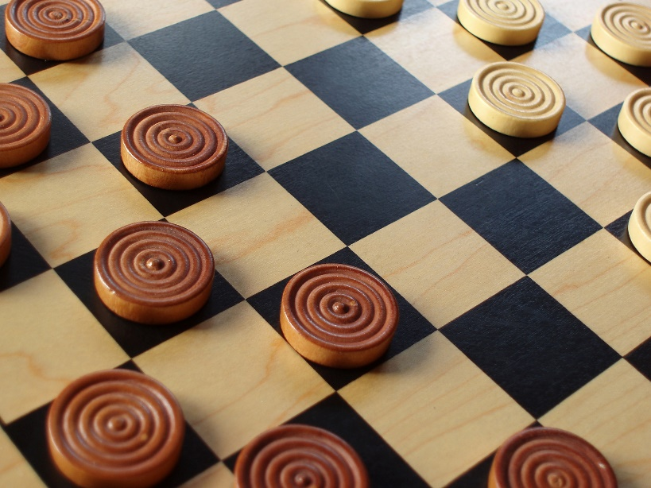

**Laboratório de Aplicações com Interface Gráfica**

**Turma 5 – Grupo 13**

Mário Esteves (201607940)

Ricardo Magalhães (201502862)

Ricardo Silva (201607942)

Faculdade de Engenharia da Universidade do Porto

**How to Play**

1. Using WebStorm IDE or any other http server (mongoose), start the game (index.html).
2. In the main menu, click the [Play] button to start playing checkers.
3. The white pieces start first, player 1 selects the tile with the piece to play, and then selects the tile where he wants to play in order to execute a play.
4. Board will rotate, and then player 2 does the same with one black piece.
5. In order to eliminate the pieces of the board, the player can ‘eat’ the other player pieces, in the following situation:
6. It’s possible to stop the game anytime using the [Surrender] button.
7. If a piece reach the other end of the board, will turn into king, which allows he player to do plays in both ways of the board. A King piece can be identified by two pieces overlapped.
8. The game will end when one of the players runs out of pieces and game over screen will pop up.
9. There you can play a new game or watch the replay of the played match.

**Other functionalities**

**Replay**

It’s possible to watch a replay of the last game played. In the main menu or the game end menu, there’s a button called [Watch Replay]. One can exit the replay screen by hitting [Menu] button or wait a few seconds after the end of the replay and the game over menu will come up.

**Score**

One can see the current score of the game in the top right corner of the screen. This shows the number of pieces in the board for both black and white pieces.

**Timer**

Each player has a 30 seconds of play turn, which can be seen in the top of the screen. If the player doesn’t do a play in 3 seconds, the game will automatically [Surrender] and the other player wins.

**Undo play**

By pressing the [Undo] button, the player can undo its play, and play again.

**Selecting the piece**

In order to select the piece to play, the player must click on the piece he wants to play, and the tile will be highlighted. Then, the player has to click on the tile he wants to play in order to execute the play.

**Auxiliary Board**

There are two auxiliary boards, one for black pieces and another for white pieces, in order to give the players a visual display of the ‘eaten’ pieces.